21.37: a) 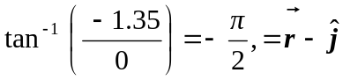 b) 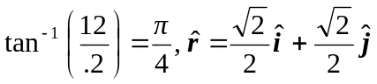
c) 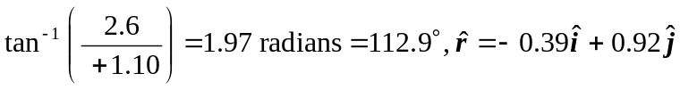 (Second quadrant).

